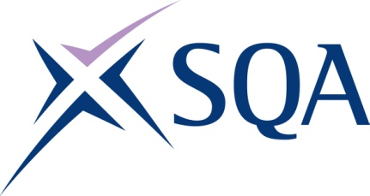

Qualification structure for SQA Level 4 Certificate in Maritime Studies: Tug Master less than 3000 gross tonnage

SQA Qualification Code: GK1V 63

Ofqual’s Qualification Code: 601/5024/5

Total Qualification Time: 330 hours
Minimum Guided Learning Hours: 265

Credit value: 33

To gain the qualification, learners must complete all FIVE Mandatory units to achieve a total of 33 credits (330 TQT)

Please note: It is important that the SQA Unit codes are used in all your recording documentation and when your results are communicated to SQA.

Mandatory Units: Learners must achieve all 33 credits

SQA Unit Code | Unit Title | Regulator’s Unit code | Level | Credit value | GLH | TQT
H8J5 63 | Manage Personnel on Board a Vessel | H/602/5406 | 4 | 8 | 62 | 80
H8J6 63 | Manage Vessel Navigation | D/602/5372 | 4 | 8 | 62 | 80
H8J7 63 | Manage Vessel Maintenance | R/602/5417 | 4 | 5 | 42 | 50
H8J8 63 | Manage Vessel Operations | D/602/5386 | 4 | 8 | 62 | 80
H8J9 63 | Take Charge of Medical Care on Board a Vessel | Y/602/5449 | 4 | 4 | 37 | 40

